**Artificial Neural Networks**

*Exercise Session 3 – Unsupervised learning and SOM,*

*report by,*

*Marimuthu Ananthavelu (r0652832), KU Leuven.*

***Hopfield neural network for Character recognition:***

Hopfield recurrent neural networks are the associative memories which works based upon the stored patterns i.e. given the partial information, the rest of the pattern is recalled. This work demonstrates the capability of Hopfield neural network to recall the original characters given the noisy character dataset. The network is given with the original characters set to learn from and later provided with noisy data with varying level. Hopfield network works based upon the analogy of having two neurons had been ‘on’ at a time, their synaptic connection is strengthened. The next time, some of them are activated, they will activate each other.

Hopfield networks come with energy function

H $=-1/2\sum_{i,j}^{n}{Wi,j Si Sj}$ with $Wij=Wji$ and $Wii≠Wii$

which is either decreasing always or stay constant for convergence.

The activation dynamics is based upon the function

$S+=sign(XjwijSj)$ where >0 indicates the attractor 1 and <0 provides -1.

The following figure shows the various combinations of Attractors (Original letters), noisy digits (after adding noise to the original letters), and the reconstructed noisy digits using Hopfield network.

***Noise level: 1% ; Number of iterations: 1***

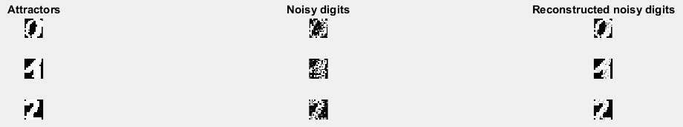

The reconstruction looks possible for all the digits with a very little noise and the network can be able to efficiently recall the original stored pattern.

***Noise level: 5% ; Number of iterations: 1***

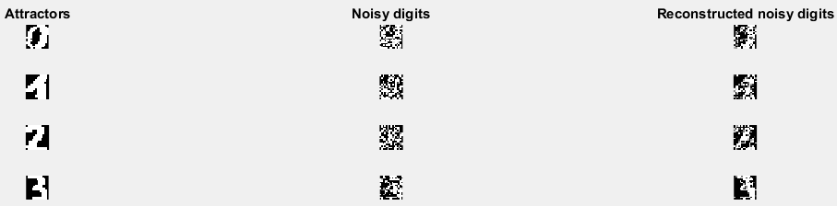

Looking at the reconstructed noisy digits, it looks like the Hopfield network finds it difficult to retrieve the Attractors with increased noise level and number of iterations, though they appear to be predicting.

***Noise level: 5% ; Number of iterations: 100***

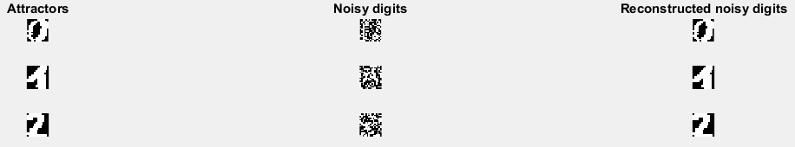

With increased number of iterations, the network can effectively recall the original letters with their memory levels. Thus, the accuracy of the Hopfield neural network comes at the expense of memory requirements which is a disadvantage to have.

***Elman Neural network:***

Elman recurrent neural network are the contextual units which is a two-layer neural network with ‘tansig’ neurons in hiddel layer and ‘purelin’ neurons in an output layer and a feedback from the hidden layer to the input. The feedback comes with delay of one step and Elman network can detect and generate time-varying patterns which makes it suitable for time-series predictions applications.

The Elman network architecture is as below;

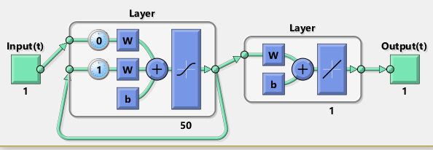

In this exercise, we use Elman network on the given Hammerstein system time series data. The results are as below;



Considering the performance of the network and the required memory complexity of the same, Elman recurrent neural network is less preferred for real time applications.